Module 01 Course Project – Hello World!

Tracy Brevig

Rasmussen College

COURSE#: W110/COP1801 Section 01 Javascript

Instructor’s Name: Kimberly Powell

February 13, 2021

**Screenshot of uploaded page:**

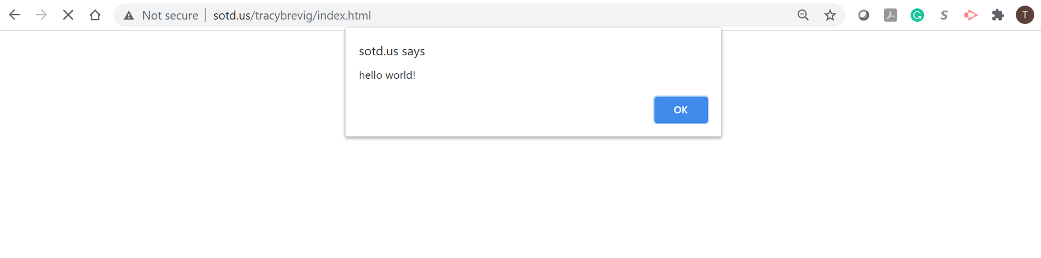

Link to SOTD URL:

<http://sotd.us/tracybrevig/index.html>

Link to GitHub repository:

<https://github.com/tbrevig/COP1801_Javascript>